CSCI-3287, Project1

Chen Hao Cheng

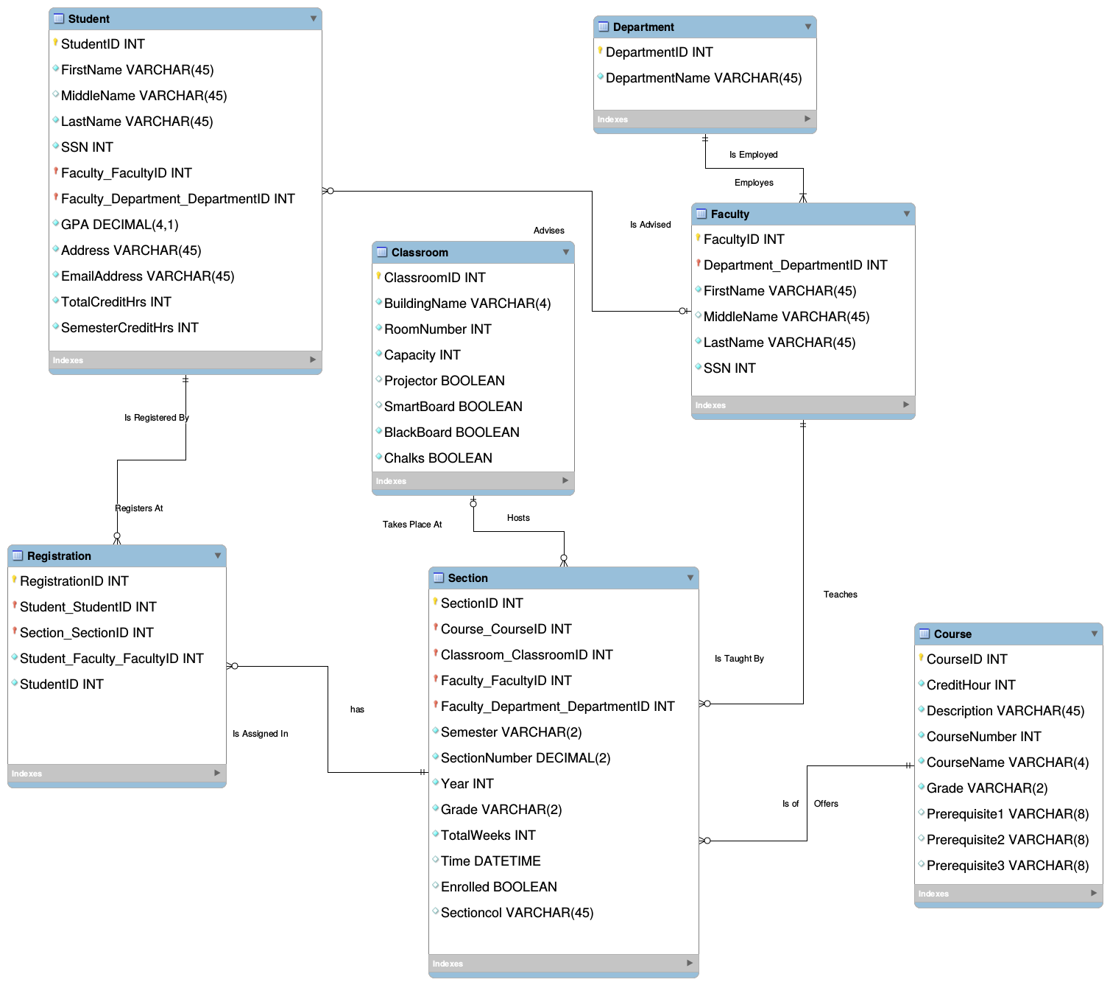

SET @OLD_UNIQUE_CHECKS=@@UNIQUE_CHECKS, UNIQUE_CHECKS=0;

SET @OLD_FOREIGN_KEY_CHECKS=@@FOREIGN_KEY_CHECKS, FOREIGN_KEY_CHECKS=0;

SET @OLD_SQL_MODE=@@SQL_MODE, SQL_MODE='TRADITIONAL,ALLOW_INVALID_DATES';

-- -----------------------------------------------------

-- Schema mydb

-- -----------------------------------------------------

-- -----------------------------------------------------

-- Schema mydb

-- -----------------------------------------------------

CREATE SCHEMA IF NOT EXISTS `mydb` DEFAULT CHARACTER SET utf8 ;

USE `mydb` ;

-- -----------------------------------------------------

-- Table `mydb`.`Department`

-- -----------------------------------------------------

CREATE TABLE IF NOT EXISTS `mydb`.`Department` (

`DepartmentID` INT NOT NULL AUTO_INCREMENT,

`DepartmentName` VARCHAR(45) NOT NULL,

PRIMARY KEY (`DepartmentID`))

ENGINE = InnoDB;

-- -----------------------------------------------------

-- Table `mydb`.`Faculty`

-- -----------------------------------------------------

CREATE TABLE IF NOT EXISTS `mydb`.`Faculty` (

`FacultyID` INT NOT NULL AUTO_INCREMENT,

`Department_DepartmentID` INT NOT NULL,

`FirstName` VARCHAR(45) NOT NULL,

`MiddleName` VARCHAR(45) NULL,

`LastName` VARCHAR(45) NOT NULL,

`SSN` INT NOT NULL,

PRIMARY KEY (`FacultyID`, `Department_DepartmentID`),

INDEX `fk_Faculty_Department1_idx` (`Department_DepartmentID` ASC),

CONSTRAINT `fk_Faculty_Department1`

FOREIGN KEY (`Department_DepartmentID`)

REFERENCES `mydb`.`Department` (`DepartmentID`)

ON DELETE NO ACTION

ON UPDATE NO ACTION)

ENGINE = InnoDB;

-- -----------------------------------------------------

-- Table `mydb`.`Student`

-- -----------------------------------------------------

CREATE TABLE IF NOT EXISTS `mydb`.`Student` (

`StudentID` INT NOT NULL AUTO_INCREMENT,

`FirstName` VARCHAR(45) NOT NULL,

`MiddleName` VARCHAR(45) NULL,

`LastName` VARCHAR(45) NOT NULL,

`SSN` INT NOT NULL,

`Faculty_FacultyID` INT NULL,

`Faculty_Department_DepartmentID` INT NULL,

`GPA` DECIMAL(4,1) NOT NULL,

`Address` VARCHAR(45) NOT NULL,

`EmailAddress` VARCHAR(45) NOT NULL,

`TotalCreditHrs` INT NOT NULL,

`SemesterCreditHrs` INT NOT NULL,

PRIMARY KEY (`StudentID`, `Faculty_FacultyID`, `Faculty_Department_DepartmentID`),

INDEX `fk_Student_Faculty1_idx` (`Faculty_FacultyID` ASC, `Faculty_Department_DepartmentID` ASC),

CONSTRAINT `fk_Student_Faculty1`

FOREIGN KEY (`Faculty_FacultyID` , `Faculty_Department_DepartmentID`)

REFERENCES `mydb`.`Faculty` (`FacultyID` , `Department_DepartmentID`)

ON DELETE NO ACTION

ON UPDATE NO ACTION)

ENGINE = InnoDB;

-- -----------------------------------------------------

-- Table `mydb`.`Course`

-- -----------------------------------------------------

CREATE TABLE IF NOT EXISTS `mydb`.`Course` (

`CourseID` INT NOT NULL AUTO_INCREMENT,

`CreditHour` INT NOT NULL,

`Description` VARCHAR(45) NOT NULL,

`CourseNumber` INT NOT NULL,

`CourseName` VARCHAR(4) NOT NULL,

`Grade` VARCHAR(2) NOT NULL,

`Prerequisite1` VARCHAR(8) NULL,

`Prerequisite2` VARCHAR(8) NULL,

`Prerequisite3` VARCHAR(8) NULL,

PRIMARY KEY (`CourseID`))

ENGINE = InnoDB;

-- -----------------------------------------------------

-- Table `mydb`.`Classroom`

-- -----------------------------------------------------

CREATE TABLE IF NOT EXISTS `mydb`.`Classroom` (

`ClassroomID` INT NOT NULL AUTO_INCREMENT,

`BuildingName` VARCHAR(4) NOT NULL,

`RoomNumber` INT NOT NULL,

`Capacity` INT NOT NULL,

`Projector` TINYINT(1) NULL,

`SmartBoard` TINYINT(1) NULL,

`BlackBoard` TINYINT(1) NOT NULL,

`Chalks` TINYINT(1) NOT NULL,

PRIMARY KEY (`ClassroomID`))

ENGINE = InnoDB;

-- -----------------------------------------------------

-- Table `mydb`.`Section`

-- -----------------------------------------------------

CREATE TABLE IF NOT EXISTS `mydb`.`Section` (

`SectionID` INT NOT NULL AUTO_INCREMENT,

`Course_CourseID` INT NOT NULL,

`Classroom_ClassroomID` INT NULL,

`Faculty_FacultyID` INT NOT NULL,

`Faculty_Department_DepartmentID` INT NOT NULL,

`Semester` VARCHAR(2) NOT NULL,

`SectionNumber` DECIMAL(2) NOT NULL,

`Year` INT NOT NULL,

`Grade` VARCHAR(2) NOT NULL,

`TotalWeeks` INT NOT NULL,

`Time` DATETIME NULL,

`Enrolled` TINYINT(1) NULL,

`Sectioncol` VARCHAR(45) NULL,

PRIMARY KEY (`SectionID`, `Course_CourseID`, `Classroom_ClassroomID`, `Faculty_FacultyID`, `Faculty_Department_DepartmentID`),

INDEX `fk_Section_Course1_idx` (`Course_CourseID` ASC),

INDEX `fk_Section_Classroom1_idx` (`Classroom_ClassroomID` ASC),

INDEX `fk_Section_Faculty1_idx` (`Faculty_FacultyID` ASC, `Faculty_Department_DepartmentID` ASC),

CONSTRAINT `fk_Section_Course1`

FOREIGN KEY (`Course_CourseID`)

REFERENCES `mydb`.`Course` (`CourseID`)

ON DELETE NO ACTION

ON UPDATE NO ACTION,

CONSTRAINT `fk_Section_Classroom1`

FOREIGN KEY (`Classroom_ClassroomID`)

REFERENCES `mydb`.`Classroom` (`ClassroomID`)

ON DELETE NO ACTION

ON UPDATE NO ACTION,

CONSTRAINT `fk_Section_Faculty1`

FOREIGN KEY (`Faculty_FacultyID` , `Faculty_Department_DepartmentID`)

REFERENCES `mydb`.`Faculty` (`FacultyID` , `Department_DepartmentID`)

ON DELETE NO ACTION

ON UPDATE NO ACTION)

ENGINE = InnoDB;

-- -----------------------------------------------------

-- Table `mydb`.`Registration`

-- -----------------------------------------------------

CREATE TABLE IF NOT EXISTS `mydb`.`Registration` (

`RegistrationID` INT NOT NULL,

`Student_StudentID` INT NOT NULL,

`Section_SectionID` INT NOT NULL,

`Student_Faculty_FacultyID` INT NOT NULL,

`StudentID` INT NOT NULL AUTO_INCREMENT,

PRIMARY KEY (`RegistrationID`, `Student_StudentID`, `Section_SectionID`),

INDEX `fk_Registration_Student1_idx` (`Student_StudentID` ASC, `Student_Faculty_FacultyID` ASC),

INDEX `fk_Registration_Section1_idx` (`Section_SectionID` ASC),

CONSTRAINT `fk_Registration_Student1`

FOREIGN KEY (`Student_StudentID`)

REFERENCES `mydb`.`Student` (`StudentID`)

ON DELETE NO ACTION

ON UPDATE NO ACTION,

CONSTRAINT `fk_Registration_Section1`

FOREIGN KEY (`Section_SectionID`)

REFERENCES `mydb`.`Section` (`SectionID`)

ON DELETE NO ACTION

ON UPDATE NO ACTION)

ENGINE = InnoDB;

SET SQL_MODE=@OLD_SQL_MODE;

SET FOREIGN_KEY_CHECKS=@OLD_FOREIGN_KEY_CHECKS;

SET UNIQUE_CHECKS=@OLD_UNIQUE_CHECKS;

Section 3: Assumption

* There are 700 new students in average join the university
* The SSN number was used as an identifier for students prior to the implementation of PC-based system in 1997
* If the course if full, the capacity attribute will reach maximum. Same as the section size
* Faculty must have SSN with 5-digit EmployeeID
* There must be a description in each course
* Each classroom has at least a blackboard and chalks
* For each course, the grade is 2 characters such as B+
* Since the school operates three semesters, so there is a semester attribute in section table
* Prerequisite course is 8 characters long (i.e. CSCI3287)
* Each course carries credit-hours between 1 to 4
* No student can take more than 18 credit-hours each semester
* Each semester represented by 2 characters (Spring: SP, Fall: FL, Summer: SM)